Grant Proposal Application 2024
 | Applicant Organization: |  | Email address | Phone number
 | Contact Person:
 | Project Location:
 | Ownership:

your project name goes here
In the space below, provide a descriptive overview of the existing site including its physical location, the needs you intend to address with this project, and your project goals. On the next page, include photographs that help to describe needs and goals.
Select this text and type an overview of your project here.

Replace the stock photos below with photos of your existing site. Select and replace this text with your own description of the photos you provide.
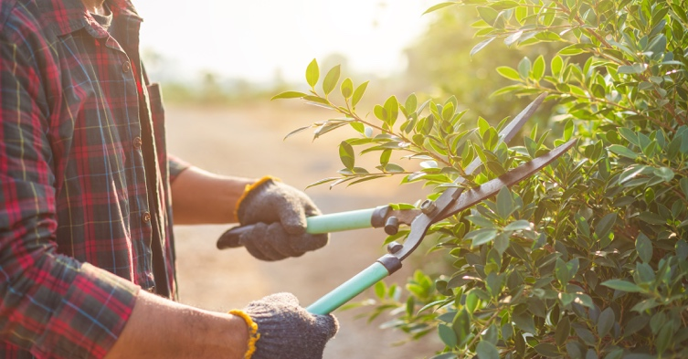

Part 2: project narrative
Using the information provided in the guidance document, provide a full description of the project plan including expected results and benefits to the community, the resources you have in place or plan to acquire, and plans for irrigation and maintenance for sustainability of the project. Provide a landscape diagram showing your planting plan and fill out the forms provided for your timeline, plants, and materials lists.

Select this text and begin typing your narrative here.

Landscape Diagram
Replace the diagram below with a photo of your landscape plan. (Don’t worry about how pretty it is…just like your math teacher, we want you to show us your work!) When you create your diagram, you should number plants and trees on the diagram to match the numbers in your plant list below. Replace this text with a caption of your own.
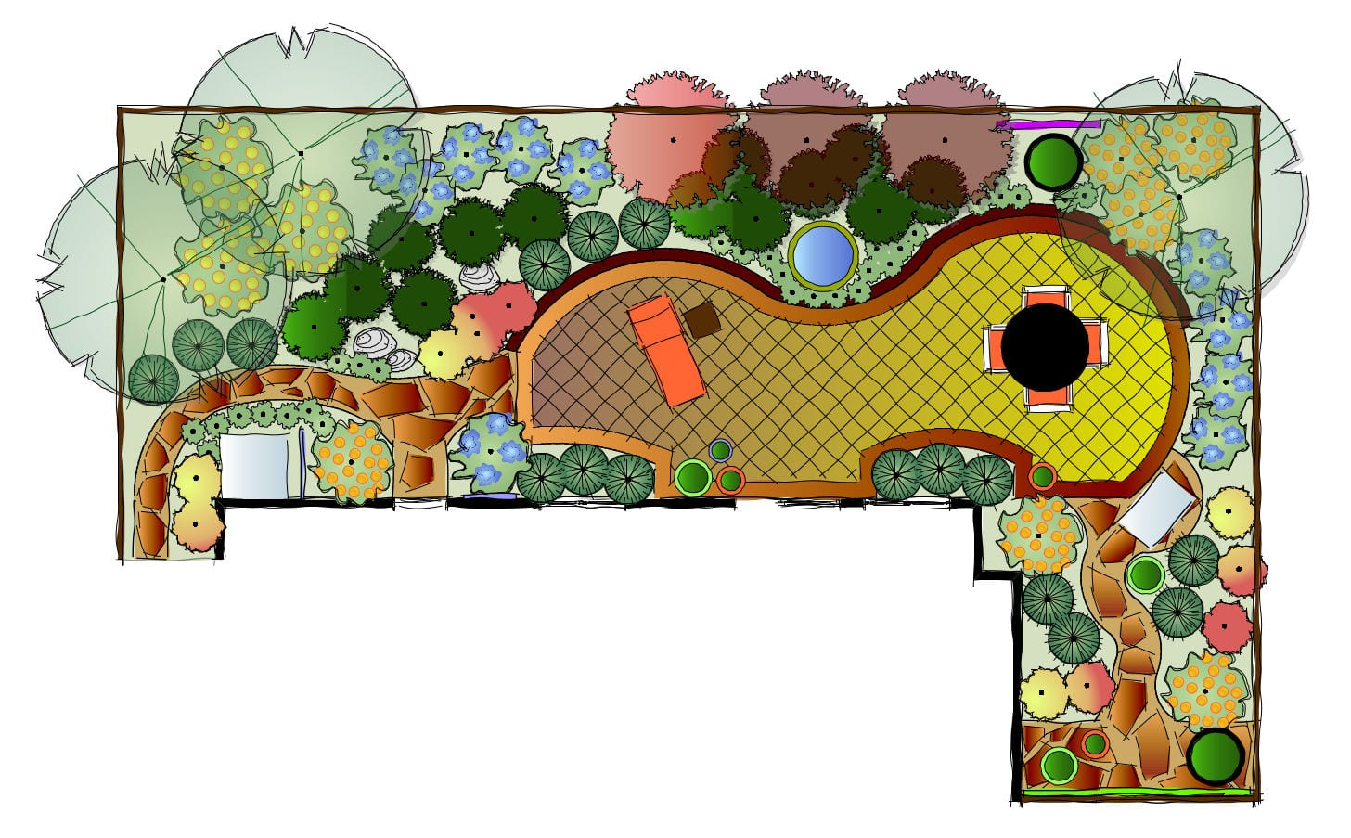

Plant List
Provide a complete list of project purchases for which you will seek reimbursement from Columbia Green. See page 2 of the guidance document for allowed and disallowed expenses. Add or delete rows as needed.

Plants, Trees, Soil Amendments & Mulch | Description
e.g.,  2 - 10 gal. Scarlett Oak Trees | This red oak species is native to South Carolina will provide shade and fall color. Grows 50-80 feet with 45–60-foot spread.

Other Materials and Plants
In the table below, list materials that will be needed to complete your project but are not reimbursable by Columbia Green as well as any additional plants you plan to include. We ask that you list these to provide a complete view of what your project will require of other funding sources.
Materials | Description
e.g., 100 sq. ft. paving brick | To be used for the patio seating area.

Implementation Timeline
Provide all important dates and milestones for your project. Note that except for the end date for the project, all entries in this table are for illustrative purposes only. Replace with wording and dates that make sense for your project. Alternatively, you may delete the table and provide you implementation timeline as a narrative.

Description | Start Date | End Date | Duration
Project Start | 1/9/23 | 12/31/25 | 12 months
Milestone 1:
Milestone 2:
Phase 1 Complete |  | 2/9/25
Milestone 3:
Milestone 4:
Phase 2 Complete |  | 6/9/25
Etc.

part 3: Budget
Provide a complete budget for your project. Include the names of vendors from whom you received cost estimates. Place reimbursable costs for Columbia Green grant in the column marked CGG Costs. Place non-reimbursable costs in the column marked Other Costs
Item | Vendor | Price | Quantity | CGG Cost | Other Cost

